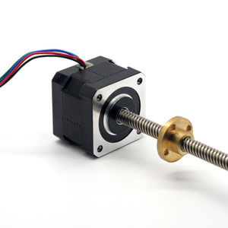

42mm Linear Hybrid Stepper Series

**SPECIFICATIONS:**

